What is BLACK Box Testing? Techniques, Types & Example

Black Box Testing
Black Box Testing is a software testing method in which the functionalities of software applications are tested without having knowledge of internal code structure, implementation details and internal paths. Black Box Testing mainly focuses on input and output of software applications and it is entirely based on software requirements and specifications. It is also known as Behavioral Testing.
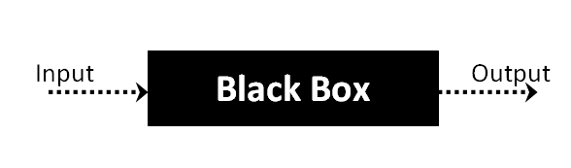
The above Black-Box can be any software system you want to test. For Example, an operating system like Windows, a website like Google, a database like Oracle or even your own custom application. Under Black Box Testing, you can test these applications by just focusing on the inputs and outputs without knowing their internal code implementation. Consider the following video tutorial-

Black Box Testing Techniques
Following are the prominent test strategy amongst the many used in Black box Testing
- Equivalence Class Testing: It is used to minimize the number of possible test cases to an optimum level while maintains reasonable test coverage.
- Boundary Value Testing: Boundary value testing is focused on the values at boundaries. This technique determines whether a certain range of values are acceptable by the system or not. It is very useful in reducing the number of test cases. It is most suitable for the systems where an input is within certain ranges.
- Decision Table Testing: A decision table puts causes and their effects in a matrix. There is a unique combination in each column.

Types of Black Box Testing
There are many types of Black Box Testing but the following are the prominent ones –
- Functional testing – This black box testing type is related to the functional requirements of a system; it is done by software testers.
- Non-functional testing – This type of black box testing is not related to testing of specific functionality, but non-functional requirements such as performance, scalability, usability.
- Regression testing is done after code fixes, upgrades or any other system maintenance to check the new code has not affected the existing code.

How to do Black Box Testing in Software Engineering
Here are the generic steps followed to carry out any type of Black Box Testing.
- Initially, the requirements and specifications of the system are examined.
- Tester chooses valid inputs (positive test scenario) to check whether SUT processes them correctly. Also, some invalid inputs (negative test scenario) are chosen to verify that the SUT is able to detect them.
- Tester determines expected outputs for all those inputs.
- Software tester constructs test cases with the selected inputs.
- The test cases are executed.
- Software tester compares the actual outputs with the expected outputs.
- Defects if any are fixed and re-tested.

Tools used for Black Box Testing:
Tools used for Black box testing largely depends on the type of black box testing you are doing.
- For Functional/ Regression Tests you can use – QTP and Selenium
- For Non-Functional Tests, you can use – Loadruner and Jmeter

Comparison of Black Box and White Box Testing:

Black Box Testing | White Box Testing
the main focus of black box testing is on the validation of your functional requirements. | White Box Testing (Unit Testing) validates internal structure and working of your software code
Black box testing gives abstraction from code and focuses on testing effort on the software system behavior. | To conduct White Box Testing, knowledge of underlying programming language is essential. Current day software systems use a variety of programming languages and technologies and its not possible to know all of them.
Black box testing facilitates testing communication amongst modules | White box testing does not facilitate testing communication amongst modules

Boundary Value Analysis (BVA) and Equivalence Partitioning (EP) are two well-known black-box testing techniques used in software testing services in the UK. These techniques ensure comprehensive test coverage and aids in identifying potential defects in software applications.
These techniques are useful for parameterised input fields, where input values vary within specific ranges or categories. They are also used to improve the efficiency and thoroughness of testing, particularly for input-driven functionalities. Let’s explore each technique in detail:

Equivalence Partitioning (EP)
Definition: Equivalence Partitioning is a testing technique that divides the input space of a software component or system into partitions or classes of equivalent input values. The goal is to test representative values from each partition because it is assumed that if one value in a partition behaves a certain way, other values in the same partition will behave similarly. EP is commonly used to reduce the number of test cases while still achieving effective test coverage.
Process
- Identify Input Conditions: Understand the input conditions or requirements for the software module you are testing.
- Divide Inputs into Classes: Divide the inputs into groups or partitions. These groups should be such that the software behaves the same way for any input within the same partition.
- Select Representative Values: From each partition, select a representative value for testing. It is enough to select one value from each partition as they should produce similar results.
- Test the Representative Values: Use the selected values for testing. This significantly reduces the number of test cases needed to achieve good coverage.
Advantages
- It reduces the total number of test cases needed to achieve good coverage.
- It ensures that each class of input is adequately tested.
- Example: If a software function accepts values from 1 to 100, you might partition this range into four classes: 1-10, 11-50, 51-90, and 91-100. Then, you’d choose one value from each class for testing.
- For example, to test an age restriction system for opening an account at a bank. In the specification, the user is required to be over 18 to be able to open their own account. To test this system, first, we must identify the range of ages (or partitions) that can and cannot create accounts as below:
- Valid partition: age>= 18. Input value: 19
Invalid partition: 0<=age<18. Input value: 5
Please note that we have identified 2 partitions, not just the one
mentioned in the specification. As a tester, it is important to test every possibility, especially the ones that are not specified yet. In our experience, that’s where most of the bugs are found, as missing information in specification can become a developer’s mistake, then later translate into a defect in the system.
- However, all the possibilities should still come from the realm of reality: as in this case, the age must not be smaller than 0. If a system allows input negative value into age, the test should not be connected with the “the user is required to be over 18” requirement, but it should be for a logical validation error such as “Age cannot be negative”.
- After we identify the partitions, we only have to choose 1 value from each partition and test those values. In this case, we chose the age value of 19 for the valid partition and 5 for the invalid partition. One might wonder if we have missed some values: There are 19 numbers between 0 and 18 in the invalid partition and even more numbers from the valid partition, and we only test 1 in each of them.
- It is an understandable concern, but this is how Equivalent Class Partitioning works: To cover every partition with the lowest number of test cases possible. If you want to not only cover every partition but also check their range, you will want to use the next technique.
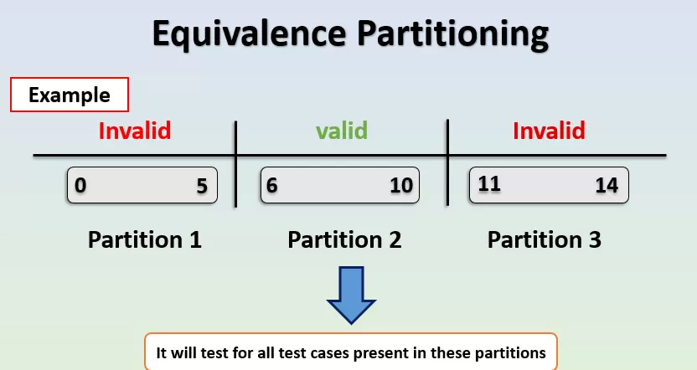

Boundary Value Analysis (BVA)
Definition: Boundary Value Analysis is a testing technique that focuses on the boundary or edge values of input ranges. It’s based on the assumption that errors often occur near the extremes of input ranges. The idea is to test values at or near the boundaries of equivalence partitions because defects are more likely to occur in these areas.
Process
- Identify Input Boundaries: Identify the minimum and maximum values that the software can accept for a given input.
- Select Boundary Values: Choose values that are just inside and just outside the identified boundaries.
- Test the Boundary Values: Use these selected values for testing.
Advantages
- It targets areas where errors are more likely to occur.
- It provides thorough testing without an exhaustive number of test cases.
- Example: If a software function accepts values from 1 to 100, you’d focus on testing values like 0, 1, 2, 99, 100 and 101.

Automating tests for BVA and ECP can be a great way to save time and ensure accuracy in your testing. If you want to automate your BVA and ECP tests, 5x faster, fill out this form and let us help you!
Connect With Us

Comparison
- In Boundary Value Analysis we identify the errors at the boundaries of input data, whereas in Equivalence Partitioning the input data is divided into partitions of valid and invalid values.
- Equivalence Partitioning is more concerned with grouping inputs that should produce similar results, while Boundary Value Analysis focuses on testing the boundaries of input ranges.
- Boundary Value Analysis help decreasing the testing time due to a lesser number of test cases from infinite to finite, whereas Equivalence Partitioning reduce the number of test cases to a defined list of testable test cases covering maximum possibilities.
Remember, these techniques are most effective when used in conjunction with other testing methods and should be applied based on the specific requirements and characteristics of the software being tested.

Benefits of these techniques
- Effective Test Coverage: EP and BVA help ensure that various input scenarios are tested without an exhaustive number of test cases, making testing more efficient.
- Defect Detection: By focusing on equivalence classes and boundary values, these techniques are effective at identifying defects that might go unnoticed with random or ad-hoc testing.
- Documentation: EP and BVA provide clear guidelines for test case selection, which can be documented and shared with the testing team, making testing more structured and repeatable.
In summary, Equivalence Partitioning and Boundary Value Analysis are systematic and structured approaches to helping testers design effective test cases that provide good coverage while focusing on critical input values and boundaries. These techniques are particularly valuable in situations where input parameters have defined ranges or categories.
